Final project report

Report for year: | 2015

1. Project information:
Provider: | Plzeň 2015, o.p.s.
Project name: | LANDART Vanished Churches
Subsidy provided: | 650,000 CZK
Subsidy invoiced: | 650,000 CZK

2. Partner information:
Partner name: | University of West Bohemia in Pilsen
Contact person: | MgA. Benedikt Tolar
Telephone: | +420 604 80 69 15
E-mail: | tolar.benedikt@gmail.com
Partner address: | Univerzitní 28, 306 14 Pilsen

3. Implementation description:

The project Vanished and Endangered Churches was created in Prof. Jiří Beránek’s Sculpture and Space Studio in the school year 2011/2012 and it was continued also in the calendar year 2014. Its goal was to draw attention to the importance of churches as spiritual centres of the past and the present. The purpose of the project is not, nor can it be, the complete renovation of these buildings. The sheer number of these knowingly devastated buildings is frightening and it would not be realistic to renovate them.
“However, their significance consists, until today, in something else. Despite their tragic destiny, they preserve memories. The memories of places – spiritual centres and gathering places for people who are able to think about things that exceed their own abilities,” says Prof. Beránek.
The aim of the project was to draw the attention of the students and the general public to the problem of abandoned and destroyed buildings – mostly belonging to the church – in areas along the Czech borders and, simultaneously, to offer to the students an interesting, current and, above all, lively topic. In collaboration with the architect Jan Soukup, Prof. Beránek selected several churches which the students used to work out land art composition designs for their course assignments and Bachelor’s theses.

The close collaboration between the European Capital of Culture Pilsen 2015 (“ECOC Pilsen 2015”) and the Ladislav Sutnar Faculty of Design and Art of the University of West Bohemia in Pilsen gave rise to the idea to turn the best of these designs into reality. That was also the beginning of the implementation of the Rediscovering Cultural Landscape project, one of the Regional Line projects of the ECOC Pilsen 2015. Four projects were selected for implementation:
- Concentration Benedikt Tolar Krasíkov Castle (Kokašice)
- The Link Vojtěch Soukup Pilsen – Pecihrádek
- Holy Trinity Altar Jakub Hadrava Otěvěky

The students received an excellent opportunity to try and create an artwork of their own and to gain valuable experience with all the necessary steps: obtaining the consent of the building owner, cooperating with local citizens and local authorities and arranging the realization of the entire work. The students also got feedback on their work directly from the people living in the respective areas. All in all, the work of young artists was readily accepted by the local inhabitants.
The highlight of each student’s work was organising an unveiling event at which the project was presented in cooperation with the ECOC 2015.
Each unveiling event had its own agenda that was presented by Prof. Beránek, sculptor and teacher at the Ladislav Sutnar Faculty of Design and Art, who also explained to the guests what land art is, why the students’ work is so important and what its benefits are. These opening events were also attended by many students of the Sutnar Faculty.
An official invitation to these events was drafted and sent by post and e-mail to all important addresses.
Each work is accompanied with an information panel containing all important information about the work, its context and its funding.

Dates of unveiling events

3rd October 2015 | Krasíkov Castle (Kokašice)
13th October 2015 | Plzeň – Pecihrádek
20th October 2015 | Otěvěky

The project included also the creation of an interactive map and a printed publication called Land Art, which documents the entire project.

“You can have plans, of course, but implementing them is a different story. Thanks to the team of the European Capital of Culture and the funding provided by the City of Pilsen, the Pilsen Region and the Ministry of Culture to support the projects, the ingenious visions of Professor Beránek and his Pilsen school have materialized over the years. That enabled the creation of a globally unique series of sculptural works and a book that documents everything – a book about artists fighting for man against the rough and ruthless course of history,” says the Dean of the Ladislav Sutnar Faculty of Design and Art Ladislav Sutnar, Josef Mištera, about the project.

Benedikt Tolar / Concentration / 3rd October 2015, 3 pm / St. Mary Magdalene Church in Krasíkov, Kokašice near Konstantinovy Lázně. The sculptor and teacher of the Ladislav Sutnar Faculty of Design and Art says about his work: “When visiting various dilapidated churches, I couldn’t have missed the St. Magdalene Church at the Krasíkov Castle. I had often passed it and had always been charmed by this ‘tooth in the landscape’, which has had its meaning since prehistoric times. When I first peeked in through the permanently open door of the church, I noticed the electricity sockets in the walls. At that moment, I recalled the somewhat pejorative expression my Christian friends and classmates at the Academy of Fine Arts in Prague used for churches. They called them ‘God’s offices’. It occurred to me that this office could do with a receiver... The altar painting I created for the St. Magdalene church is actually a fusion of a Kapoorian optical illusion, my ‘gravitational painting’ and a satellite dish.”
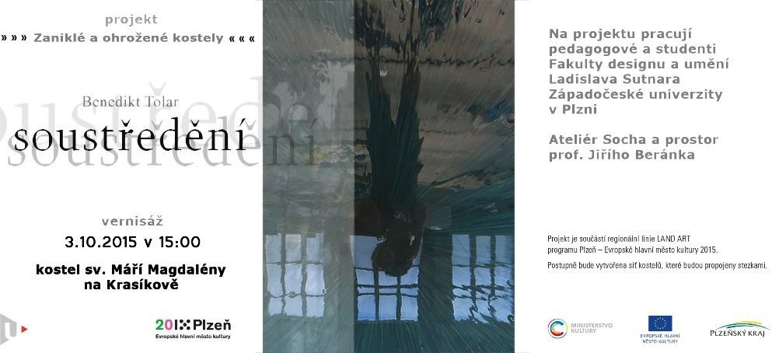

Vojtěch Soukup / The Link / 13th October 2015, 4 pm / Pecihrádek in Pilsen. Vojtěch Soukup, meanwhile a graduate of the Sculpture and Space Studio, describes the sources of inspiration for the art installation, which he created on the site of the vanished Pecihrádek fortress, as follows: “The main source of inspiration for this installation is the siege towers, which, of course, date back to a later era than the former fortress. However, they inspired me in terms of shape and construction. Let’s say that this installation captures a theoretical point in time after a siege has failed, and remnants of the fights can still be found in the ditch. For example, the siege tower, ready for use, but never used. Inspiration for the basic shapes can been seen also in various footbridges and drawbridges. In view of the Pecihrádek location, we can perceive this installation as a link (connection) between two worlds. In this respect, the installation can connect history with the present. A fortified Celtic settlement and our current reality. We can see the installation as an invitation to the past. Being aware of the past (history) is a valuable basis for any advanced civilization.”

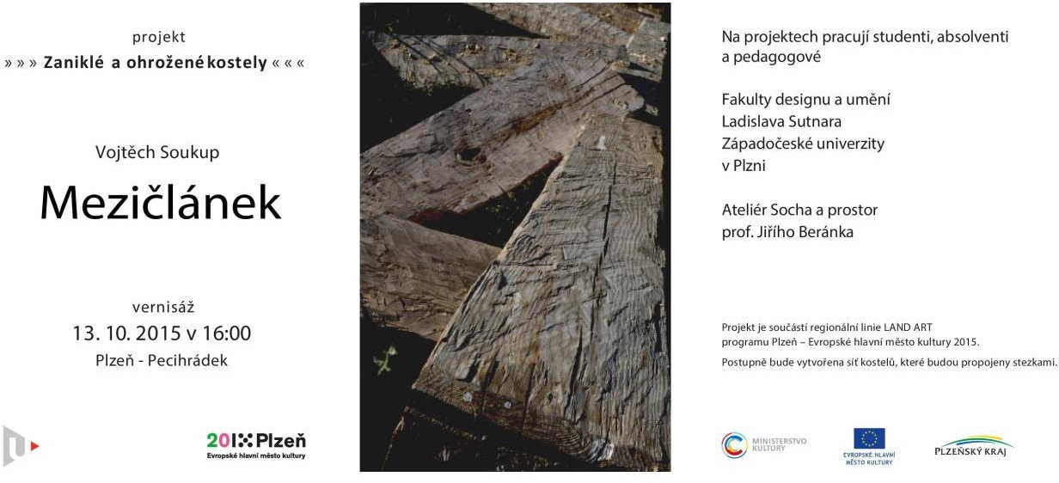

Jakub Hadrava / Holy Trinity Altar / 20th October 2015, 4 pm, Church of the Holy Trinity, Otěvěky.

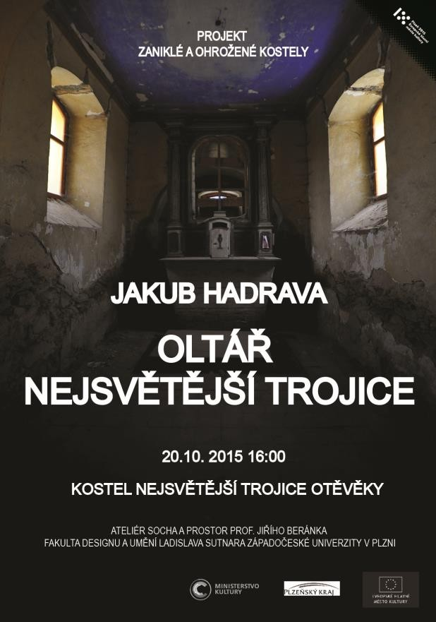
The altar painting, created by another recent graduate of the Sculpture and Space Studio, consists of three overlapping layers, which together form a unit – a painting referring to the Holy Trinity. The artist says about his work:
“Each of the layers (tin plates) represents one of the forms of God in Christian mythology, in the following order from the observer: The Father (God), the Son (Jesus Christ) and the Holy Spirit. The altar painting is made up of patterns or segments of patterns, which can be referred to as sacred geometry. This geometry is present in many animate and inanimate forms in nature, testifying to the geometric essence of the universe and the divine order, which is present in everything that surrounds us. Due to the interconnectedness of the individual elements, the image seems to ‘change in front of your eyes’ and all the time you keep finding new connections and meanings that lead – as I believe – our minds to God. The different colours and surfaces of the tin plates, the light passing through the altar and the fact that the image can be seen properly only from some angles – all this information leads us to the message rather subconsciously.”

Press overview:

http://www.regionplzen.cz/zpravodajstvi/zanikle-a-ohrozene-kostely-zvou-na-landartova-dila-85486/

http://www.plzen2015.cz/cs/akce/zanikle-a-ohrozene-kostely-2015 http://www.fdu.zcu.cz/cz/1263-zanikle-a-ohrozene-kostely-zvou-na-landartova-dila

https://www.blesk.cz/clanek/zpravy-live-kulturni-servis/346866/tri-zanikle-a-ohrozene-kostely-na- plzensku-ozivuji-sochy-studentu.html

5plus2

Artists reviving churches again
9th October 2015, 5plus2, page 15, Education
LADISLAV VAINDL University of West Bohemia in Pilsen

A unique student project helps to promote dilapidated monuments that are on the verge of destruction

PILSEN REGION / Dilapidated churches on the Krasíkov hill and in the village of Otěvěky and a vanished fortress in Pecihrádek. These are further places that have become part of the unique project Vanished and Endangered Churches. Organized by students and teachers of the Ladislav Sutnar Faculty of Design and Art of the University of West Bohemia in Pilsen, the project has been underway since 2012. “The old plans that Professor Jiří Beránek and I had developed in the early 2000s, have now been fulfilled through land art projects of the students and teachers of his studio,” says Josef Mištera, the Dean of the Sutnar Faculty. The young artists’ works revive dilapidated monuments that have been mostly left without care. “When I talked to Professor Beránek about his future position at the faculty I was about to establish in Pilsen, he was still teaching at the Academy of Arts, Architecture and Design in Prague. He said he would like to focus his future studio in Pilsen on interventions in the landscape and the environment we live in,” recalls Josef Mištera.

God’s office gets a satellite receiver

Benedikt Tolar’s remarkable installation called Concentration was unveiled in the Church of St. Mary Magdalene in Krasíkov last week. “When visiting various dilapidated churches, I couldn’t have missed the church at the Krasíkov Castle. I had often passed it and had always been charmed by this tooth in the landscape, which has had its meaning since prehistoric times,” says the artist. During his first visit, he noticed that there were electricity sockets in the church. “At that moment, I recalled the somewhat pejorative expression my Christian friends and classmates at the Academy of Fine Arts in Prague had used for churches. They called them ‘God’s offices’. It occurred to me that this office could do with a receiver... The altar painting I created for the Church of St. Magdalene is actually a fusion of a Kapoorian optical illusion, my ‘gravitational painting’ and a satellite dish,” says Tolara about his extraordinary artwork.
Unlike Tolar, Vojtěch Soukup focused on the site of the former Pecihrádek fortress in Pilsen, creating an installation called The Link. “I drew my inspiration for this installation mainly from siege towers, which, of course, date back to a later era than the former fortress. However, they inspired me in terms of shape and construction. Let’s say that this installation captures a theoretical point in time after a siege has failed, and remnants of the fights can still be found in the ditch. For example, the siege tower, ready for use, but never used,” says the graduate of the Sculpture and Space Studio. In view of the Pecihrádek location, the installation can be seen as a certain link between two worlds, he says. “In this respect, it can connect history with the present. A fortified Celtic settlement and our current reality. We can see the installation as an invitation to the past,” explains Vojtěch Soukup.

Altar decorated with sacred geometry

The last addition to the project in this year will be unveiled on 20th October in the Church of the Holy Trinity in Otěvěky. The church has received an unconventional altar created by Jakub Hadrava. “Each of the layers – tin plates – represents one of the forms of God in Christian mythology, in the following order from the observer: The Father (God), the Son (Jesus Christ) and the Holy Spirit. The altar painting is made up of patterns or segments of patterns, which can be referred to as sacred geometry. This geometry is present in many animate and inanimate forms in nature, testifying to the geometric essence of the universe and the divine order, which is present in everything that surrounds us,” explains Jakub Hadrava. He is also the author of the installation called “Believers” which has probably drawn the greatest atention to this university project aimed at saving churches so far. Three years ago, he placed sculptures of believers in the church in Luková near Manětín. People immediately nicknamed them ghosts, and visitors from all over the world starting coming to see the artwork.
For the fourth year in a row, the project points out the importance of churches as spiritual centres of the past and the present, bringing dilapidated and forgotten spiritual places in the Pilsen region back to life through artistic interventions. The purpose of the project is not, nor can it be, the complete renovation of such buildings. “The sheer number of these knowingly devastated buildings is frightening. However, their significance consists, until today, in something else. Despite their tragic destiny, they preserve memories. The memories of places – spiritual centres and gathering places for people who are able to think about things that exceed their own abilities,” says Jiří Beránek, head of the Sculpture and Space Studio.

Photo description| The Link on the site of the former Pecihrádek fortress. Photo description | A new piece of art in the church in Otěvěky.
Photo description | An extraordinary altar painting in Krasíkov. Photo author | PHOTO / 3x FACULTY ARCHIVE

Mladá fronta DNES daily

Pecihrádek guarded by a medieval catapult
13th October 2015 Mladá fronta DNES daily, page 15, Pilsen Region
University of West Bohemia in Pilsen

The goal of the young artist Vojtěch Soukup was to revive the site of the former fortress Pecihrádek in Pilsen. That is where he placed his work called The Link. “Since I come from Pilsen, I know this place very well. It is great, but, at the same time, it is forgotten. I think that it should be brought to the attention of the local people again and it should be given proper care,” says the graduate of the Faculty of Design and Art at the University of West Bohemia. Soukup’s work is part of a project called Vanished and Endangered Churches, which aims to draw attention to some of the dilapidated monuments in the Pilsen region. The project was initiated by the Faculty’s students, graduates and teachers and its most notable work so far was the sculptures of “Believers” in Luková near Manětín. People immediately nicknamed them ghosts, and visitors from all over the world starting coming to see the work. The installation at Pecihrádek is intended to point out the rich history associated with the place, Soukup says. “I was fascinated by the contrast of our Celtic and Christian roots. On the one side, there is a fortified Celtic settlement, on the other side, there is an open space near the St. George Church,” explains the young artist. He drew his inspiration mainly from siege towers. “However, they inspired me only in terms of shapes and construction. Let’s say that this installation captures a theoretical point in time after the siege has failed, and remnants of the fights can still be found in the ditch. For example, a siege tower, ready for use, but never used. My inspiration for the shape came also from various footbridges and drawbridges,” he adds, describing the scenery that you can now see at Pecihrádek. The unveiling event starts today at 4 pm.
This year has already seen the unveiling of Benedikt Tolar’s artwork Concentration in the St. Mary Magdalene Church in Krasíkov, which was also part of the project. The last work to be unveiled is Jakub Hadrava’s installation Resacralization. It will be presented at an event scheduled for the 20 October in the Church of the Holy Trinity in Otěvěky.

Photo by author | Photo: Martin Polívka, MAFRA

Regional edition | Mladá fronta DNES – Pilsen region

